27.02.2019-05.03.2019



**MIDDLE EAST TECHNICAL UNIVERSITY**

DEPARTMENT OF ELECTRICAL AND ELECTRONICS ENGINEERING

EE493 – Weekly Progress Report #13

POTATO INTEGRATED TECHNOLOGIES

A close up of a clock

Description generated with high confidence

**Design Studio Coordinator:** Arzu KOÇ

**Partners and Contact Information:**

Fatma Nur ARABACI 2030047 0533 602 75 27 arabaci.fn@gmail.com

İrem COŞKUN 2030419 0539 414 59 69 iremcoskun0@gmail.com

Aycan BEYENİR 2030328 0539 330 05 70 abeyenir@gmail.com

Berkay GÖKSU 2030757 0505 635 81 45 berkaygoksu1@gmail.com

Furkan Bahadır ELİK 2030518 0554 963 94 10 elik.bahadir@metu.edu.tr

**What has been done:**

In this week we have a lot to do in a tight schedule. After the weekly meeting, we immediately started working on the project and make test to be certain about the designs of each subsystem. In this test we observed that our proposed shooting subsystem does not satisfy our expectations.

To discuss this design change and other important topics we made an official meeting in the Company Headquarter at Sunday. In this meeting we discussed about revision of shooting subsystem, physical design of the robot and the upcoming Critical Design Review Report (CDRR).

First, we need to revise our shooting subsystem and switch to our backup plan, since our proposed shooting system fail to satisfy our performance requirements. The impact force created by servo motor on the ball is not strong enough, which will create easy to defend shots for our opponent. The illustration of the proposed backup plan in the conceptual report is shown in Figure 1. As shown in the figure, this system consists of push-pull system, which provide strong impact on the ball. To implement this design, we bought a push-pull solenoid which is shown in Figure 2. After we test the strength of the impact created by this solenoid we decided it performs better than our previous approach. Hence, in the CDRR we decided to propose this push-pull system as our solution.

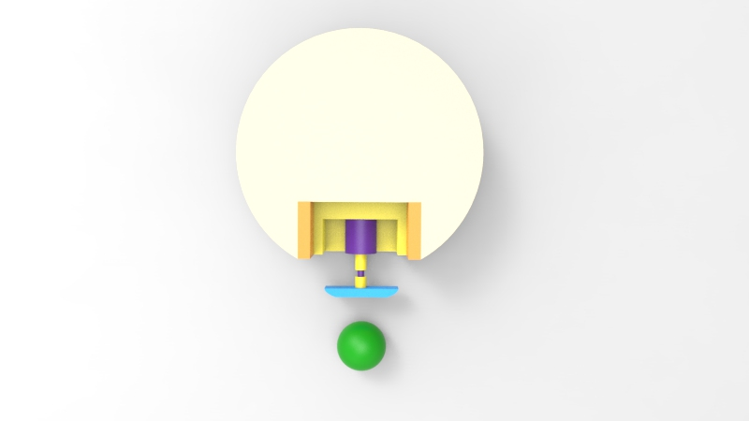

Figure 1: Illustration of the shooting subsystem

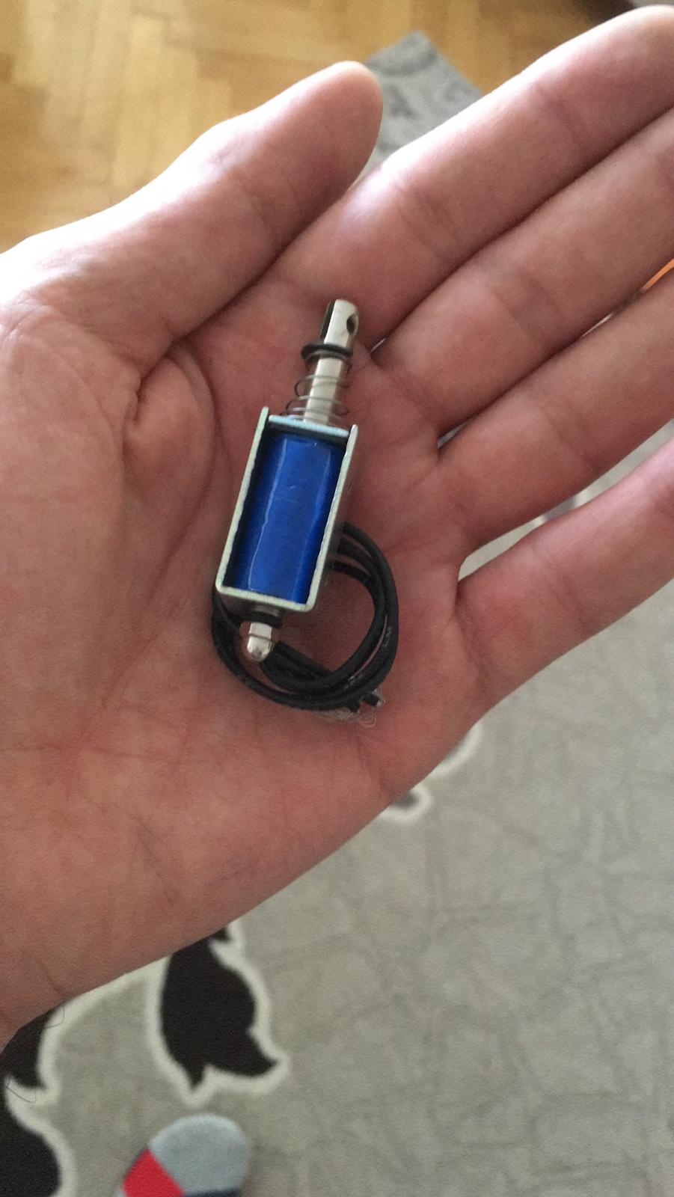

Figure 2: Push-Pull Solenoid

The other important topic in the meeting is the final design of the robot’s body and the assembly of the motors. Due to the revision in the shooting subsystem, the body design can only be done after the decision of the new shooting subsystem. Hence, we started the final design in the official meeting. In the first phase, we draw the floor plan for the motors, shooting subsystem and wheels. This plan is necessary for creating the CNC cutting the plexiglass chassis. This technical drawings for plexiglass chassis can be observed in Figure 3.

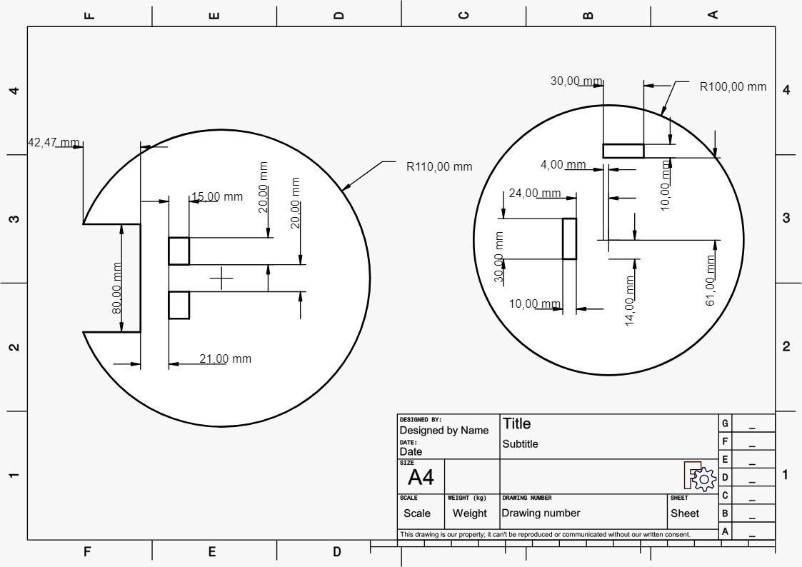

Figure 3: Technical plan for plexiglass chassis

After the design of body of the robot, we started working on the critical design review report. In the meeting we discuss the organization and content of the report by considering the evaluation rubric, description given in course website and previous feedbacks from our design studio coordinator. After we agreed on the structure of the report, we have written some parts of the report and divide some parts of the report to the team members. In our next meeting we are going to include these parts and finish this report.

**Next week’s plan**:

* CDRR report are going to be finished.
* We will start to assemble the subsystems on the robot’s body.
* The motor drive code will be optimized for the assembled body.